**How to Use a Scale/Balance**

A weighing scale or balance is used in the lab to measure quantities of solids. The terms “scale” and “balance” are often used interchangeably, although technically they do different things – a balance measures mass (i.e., grams) by measuring the amount of displacement when a weight is applied to the top of the pan; while a scale measures weight (i.e., newtons) by measuring the amount of force applied to a spring. Weight is mass x gravity, so the weight of something will change depending on the gravity; although again, in practice, the terms are sometimes used interchangeably. For example, someone might ask for the weight of a powdered chemical, when they really want to know the mass, or how much of it you have in grams.

Below is an example of an analytical balance (Fig. 1). The top of the balance has a wide pan on which the mass of an item can be measured (Fig. 1A). A balance like this can measure items ranging from ~100g down to 0.01g. To measure even smaller amounts (0.001-0.0001g) a balance with a special enclosure is typically used, with a much smaller pan. For things like powdered chemicals, a weigh boat or weigh paper can be used to contain the material (Fig. 1B). For convenience in handling, a square of weigh paper can be folded twice to form an indentation in the center. To transfer the material to be measured from its stock container to the weigh boat or paper, small spatulas are typically used. Metallic spatulas are very common, but disposable plastic spatulas are also useful (Fig. 1C). A similar disposable spatula can be made from a long, sturdy straw by cutting open one end to form a little scoop (like the straws that come with slurpees).

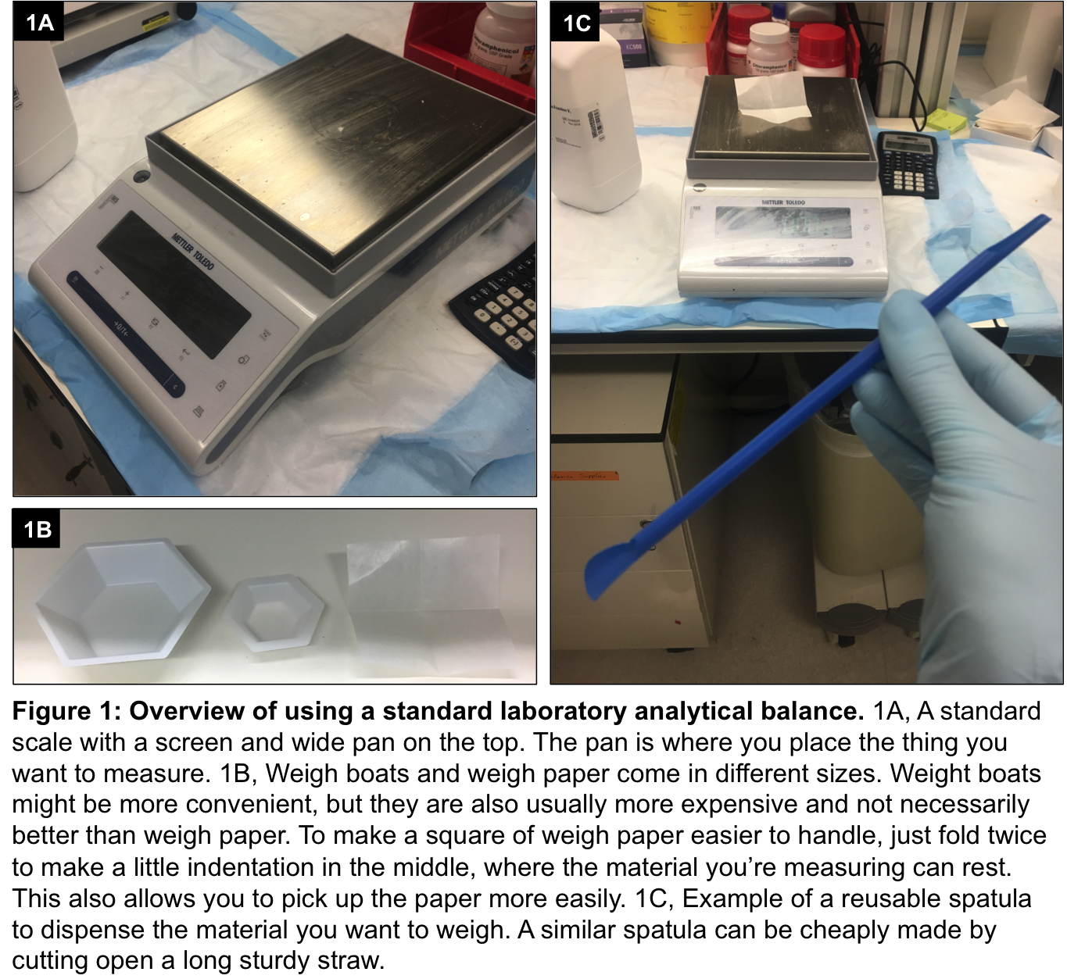

To measure the mass of something, place the weigh boat or paper on the pan of the balance (Fig. 2A). If the balance is in sleep mode, you will probably need to press the “on” button or the “tare” button for it to register the mass of the weigh paper; in the example below, this is the long dark blue “à0/Tß” button at the bottom. In this case, the weigh paper registers as being 0.22g. Say we wanted to measure out 0.7g of bovine serum albumin; since the weigh paper is 0.22g, we would have to add the bovine serum albumin until the balance registered 0.92g (0.22 + 0.7 = 0.92). Alternatively, we could tare, or “zero,” the weigh paper so that the balance would only show us the mass of the bovine serum albumin as we transfer it over. To do this, just press the tare button again and the balance should register “0.00g” (Fig. 2B) You might see some drift after taring the balance, especially for the more sensitive balances that measure a smaller range of mass. Just continue to tare until the drift goes away (if the drift is really bad, refer to the manual of your specific balance – you may have to recalibrate it. Each balance has its own calibration procedure). Then use the spatula to carefully transfer over small amounts of the material until it registers the desired amount (Fig. 2C). If you spilled any, quickly clean up the area with a kim wipe and you’re good to go.

